Application instruction manual

# How to create an admin

In order to use the application, admin accounts have to be created.

To create an admin account, perform the following steps:

1. Run the application.

2. Register as a company - Use your preferred admin login data.

3. Open the database file (backend/db.sqlite) with the sqlite DB browser of your choice (i.e. https://sqlitebrowser.org/).

4. Go to table 'user'. Note the "id" column of the user with the email you entered in step 2.

5. Go to table 'company'. Delete the row where column "userId" is equal to your noted id.

6. Go to table 'admin'. Add a new row. Insert the noted id into column "userId".

7. Write your changes to the database.

# How to edit „about us“ page

Edit the html/css code in frontend/src/app/about. The changes should be shown right away.

Application main features

The application should be intuitive and give user feedback to understand how it works. Still, the most important processes and features are explained here.

Jobs

All *accepted* jobs (see ‚acceptance status‘) are shown on the start page and can be searched and filtered. The newest *accepted* job postings are shown on top, below *featured* (see ‚featured status‘) ones. Companies can see all their job postings at „account“ - „my job postings“. Job postings can only be created if you are a *verified* company (see ‚companies‘ - ‚verification status‘).

**acceptance status**

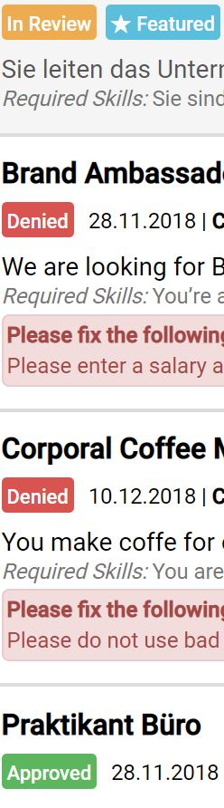

When a new job is created, it’s status is set to *in review*. It is shown on the job site as soon as it is *accepted* by an admin. If it is *denied*, an explanation by the admin is saved. If you edit parts of your job postings, their status is set to *in review*.

**"featured" status**

An admin can *feature* selected job postings. Those are marked as above and shown on top of all their lists.

Companies

Companies that are *verified* (see ‚verification status‘) can create new job postings. All companies that were *verified* once are always displayed on the „companies“ site. Account information can be seen and edited at „account“ - „account settings“.

**verification status**

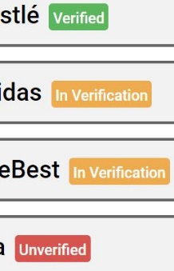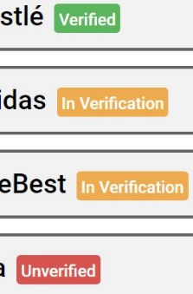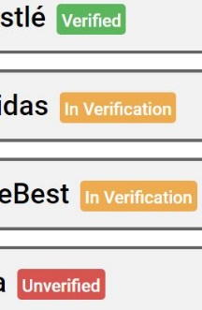

After registration, a company is at status *in verification*. An admin can then set it to *verified* or *unverified* with a message. When company information is updated, the companies status is set to *in* *verification* again (does not include user email and password though).

**"featured" status**

An admin can *feature* selected companies. Those are marked as above and shown on top of the companies list.

## Admin

Admins have all the power. They can accept or decline jobitems, verify or unverify companies and feature or unfeature both. Instead of „account settings“ and „my job postings“, he has the following sites:

**Show all – companies**

See a shortlist of all existing companies. Thought to use for spam treatment or error correction. Possibility to *feature*/*unfeature* or delete. Possibility to *verify* unverified companies or *unverify* companies that are *in review*.

**Show all – job postings**

See a shortlist of all existing job postings. Thought to use for spam treatment or error correction. Possibility to *feature*/*unfeature* or delete. Possibility to *accept* declined postings or *decline* postings that are *in review*.

**Show in review – companies**

See all companies that are on status *in review* in detail. Possibility to *verify* or *unverify*.

**Show in review – job postings**

See all job postings that are on status *in review* in detail. Possibility to *accept* or *decline*.